

Data Analytics Mini Project

Jwalna G

Program in AI-driven DA-DAF50

—

June,10th-2026

—

NYC Airbnb Market Analysis using Excel and PowerBI

INTRODUCTION
Dataset URL: https://www.kaggle.com/datasets/dgomonov/new-york-city-airbnb-open-data

NYC Airbnb Open Data dataset contains information about Airbnb listings across New York City. The dataset includes details such as listing price, room type, host information, availability, geographical location, minimum stay requirements, and customer review activity.

For this project, 49,080 records were selected and analyzed to understand Airbnb market trends, pricing behavior, host activity, room preferences, and geographical distribution of listings within New York City.

Details as follows:
- Rows: 1,000
- Columns: 22
- Data Type: Tabular
- Format: Excel / CSV

Scope of the Mini Project

The objective of this project is to perform data cleaning, preprocessing, transformation, and visualization using Excel and Power BI. The analysis focused on identifying pricing patterns, host behavior, room type preferences, review trends, availability patterns, and geographic distribution of Airbnb listings across New York City.

A. Data Pre-Processing Using Excel

1. Removing Duplicate Records

The dataset was examined using Excel’s Remove Duplicates feature to identify and eliminate duplicate entries.

2. Handling Missing Values

To ensure data quality and improve analysis accuracy, missing values were identified and validated using multiple Excel techniques.

Step 1: Identification of Blank Values Using Filter

The filter option was applied on important columns such as:
- Host Name
- Last Review
- Reviews Per Month
“(Blanks)” option visible in the filter dropdown was used to identify records containing missing values.
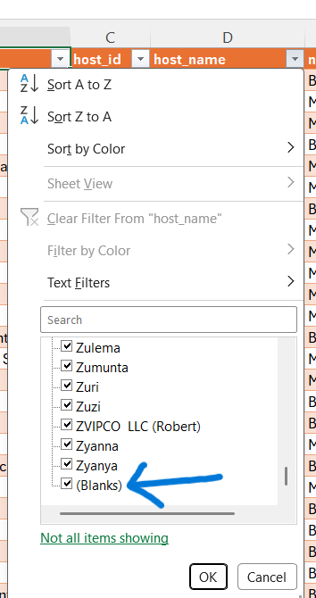

Step 2: Counting Missing Values Using COUNTBLANK Function

The Excel COUNTBLANK() function was used to calculate the total number of missing records in selected columns.

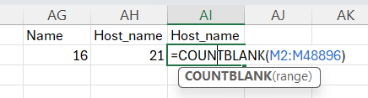
Example Formula:
=COUNTBLANK(D2:D48895)
Where:
- D = Host Name column
- 48895 = Last row of dataset

Step 3: Validation and Confirmation

After identifying missing values, a summary table was created to verify the number of blank cells in each column.

Column Name | Missing Values
- Host Name | - 16
- Last Review  - Review per month | - 21  - 10052
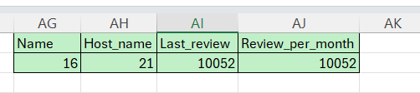

Action Taken:

The following cleaning actions were performed:

- Host Name blanks were removed or excluded.
- Missing values in Reviews Per Month were replaced with 0.
- Missing values in Last Review were handled appropriately before visualization.
- Added columns Price band, Availability band,Minimum Night Band,Review intensity,Last review Year, Host scale.

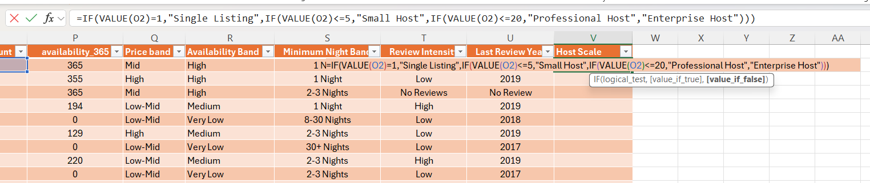
3.Data Standardization
Column formats and data types were standardized to improve consistency and analytical accuracy.

Actions Performed:
- Price converted to Numeric format.
- Availability_365 converted to Whole Number.
- Latitude and Longitude converted to Decimal Number.
- Last Review converted to Date format.

4. Creating Calculated Fields
Several new analytical columns were created to support better visualization and reporting.
1. Price Band: Listings were grouped into Budget, Low-Mid, Mid, High, and Luxury categories based on price ranges.

2. Availability Band: Availability was categorized into Very Low, Low, Medium, and High groups.

3. Minimum Night Band: Listings were categorized based on minimum stay requirements.

4. Review Intensity: Review activity was classified as Low, Moderate, High, and Very High.

5. Last Review Year: The review year was extracted from the Last Review column.
6. Host Scale: Hosts were categorized into:
- Single Listing
- Small Host
- Professional Host
- Enterprise Host

These calculated fields enabled deeper analysis and improved dashboard interactivity.

Formula as follows:
Price Band: =IF(J2<50,"Budget",IF(J2<100,"LowMid",IF(J2<200,"Mid",IF(J2<500,"High","Luxury"))))

Availability Band:
=IF(P2<=30,"Very Low",IF(P2<=120,"Low",IF(P2<=240,"Medium","High")))

Minimum Night band: =IFS(VALUE(K2)=1,"1 Night",VALUE(K2)<=3,"2-3 Nights",VALUE(K2)<=7,"4-7 Nights",VALUE(K2)<=30,"8-30 Nights",VALUE(K2)>30,"30+ Nights"
)

Review Intensity: =IF(OR(N2="",ISBLANK(N2)),"No Reviews",
IFS(VALUE(N2)<1,"Low",VALUE(N2)<3,"Moderate",VALUE(N2)<6,"High",VALUE(N2)>=6,"Very High"))

Last Review Year: =IF(M2="","No Review",YEAR(M2))

Host scale: =IF(VALUE(O2)=1,"Single Listing",IF(VALUE(O2)<=5,"Small Host",IF(VALUE(O2)<=20,"Professional Host","Enterprise Host")))

Result:The dataset became cleaner, more reliable, and suitable for visualization and dashboard.
Before
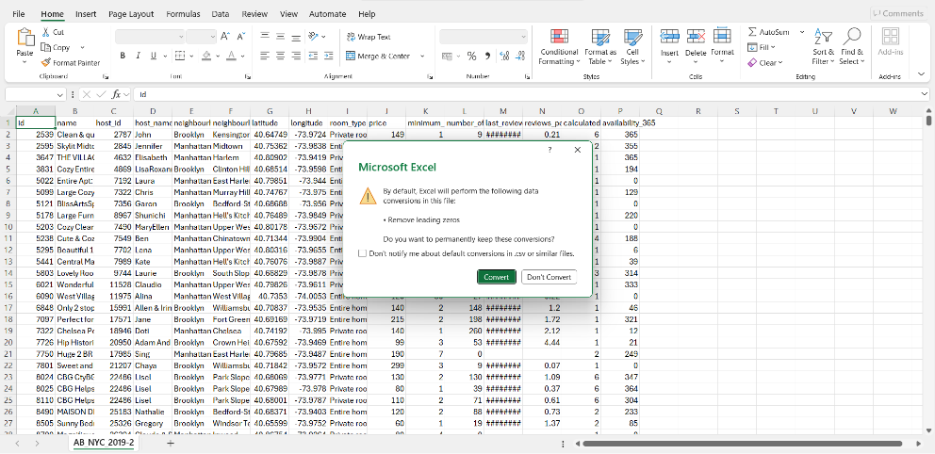
After
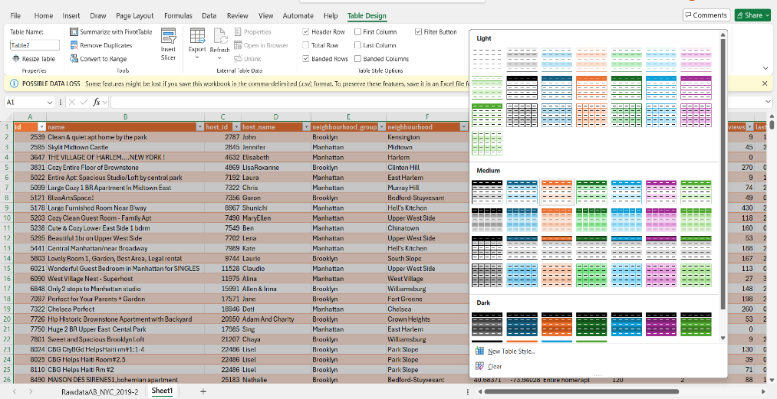

5. Filtering and Sorting
Several filters and sorting operations were performed to identify patterns within the dataset.

6. Creating Using Pivot Tables:
Pivot Tables were created in Excel to summarize and analyze Airbnb listing data efficiently. These Pivot Tables helped identify trends, patterns, and key business insights before building the Power BI dashboard.

Pivot Tables were used to:

- Summarize large volumes of Airbnb listing data.
- Compare prices across boroughs.
- Analyze room type distribution.
- Examine host activity levels.
- Evaluate review performance.
- Support dashboard creation.
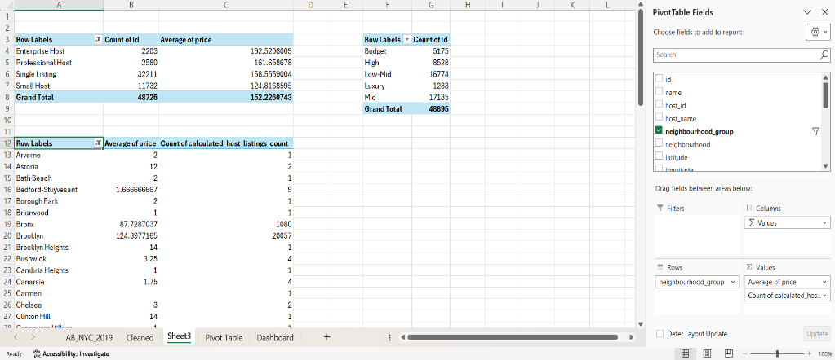

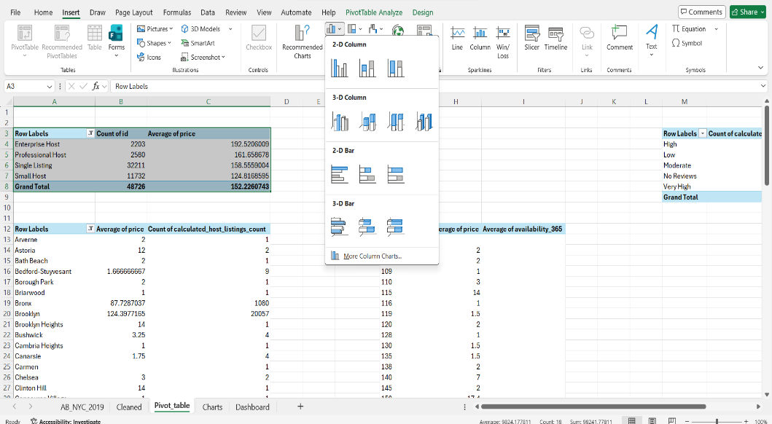

Pivot Table 1: Average Price by Borough
To identify which borough has the highest average Airbnb listing price.

Configuration
- Rows: neighbourhood_group
- Values: Average of Price

Pivot Table 2: Listings by Room Type
To determine the distribution of Airbnb listings across room categories.

Configuration

- Rows: room_type
- Values: Count of id

Pivot Table 3: Host Scale Analysis
To understand host participation in the Airbnb market.

Configuration

- Rows: Host Scale
- Values: Count of id

Pivot Table 4: Price Band Distribution
To analyze listing distribution across pricing categories.

Configuration

- Rows: Price Band
- Values: Count of id

Pivot Table 5: Review Intensity Analysis

Objective

To evaluate customer engagement based on review activity.

Configuration

* Rows: Review Intensity
* Values: Count of id

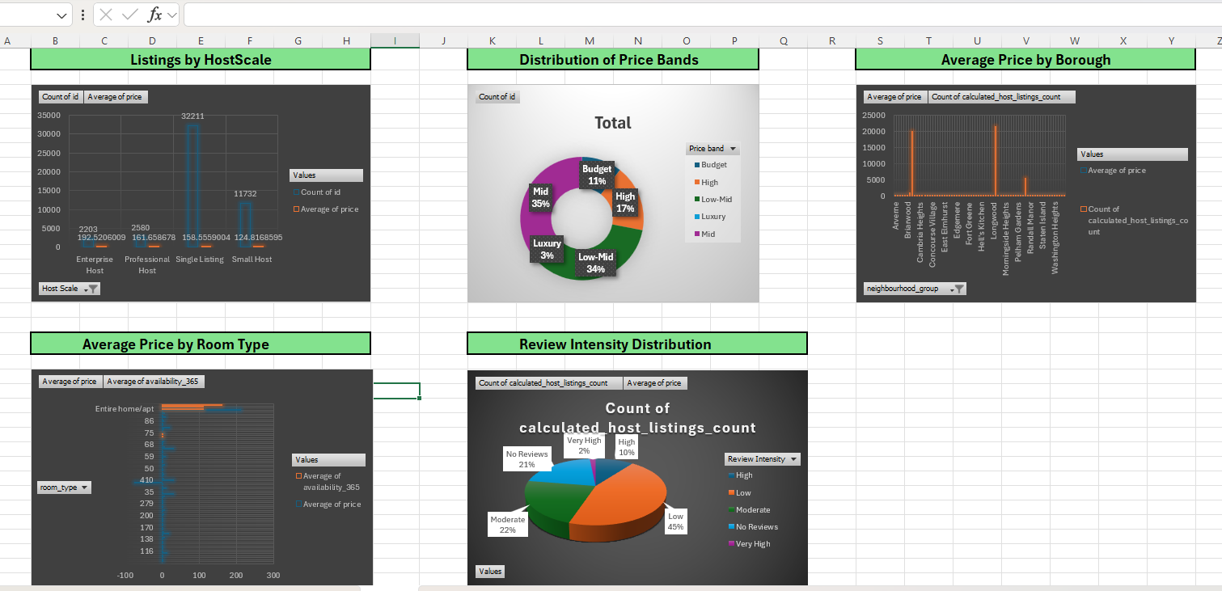

Dashboard Development:
After completing data cleaning and Pivot Table analysis, an interactive dashboard was developed in Microsoft Excel to provide a summarized view of key Airbnb market indicators.

The dashboard consists of KPI cards, charts, and slicers that allow users to analyze Airbnb listings efficiently.

KPI Metrics Created

KPI 1: Total Listings
Shows the total number of Airbnb listings included in the dataset.
Formula Used:
=COUNTA(A2:A955)

Result:
954 Total Listings

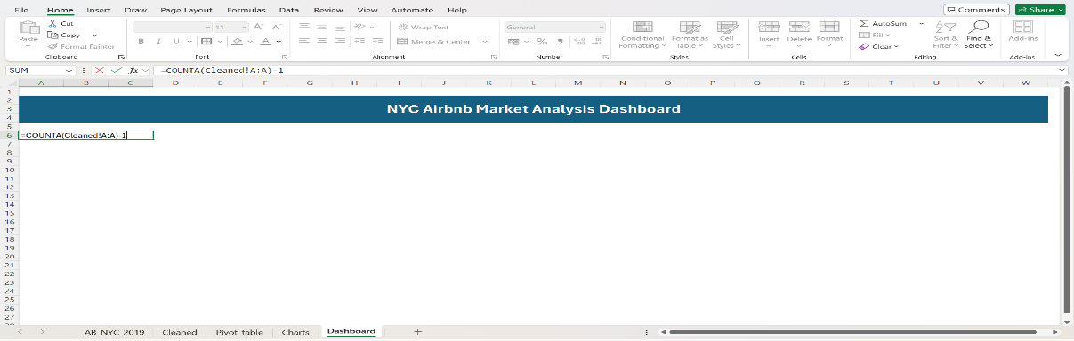

KPI 2: Average Price
Calculates the average Airbnb listing price.
Formula Used:
=AVERAGE(I2:I955)
Result:
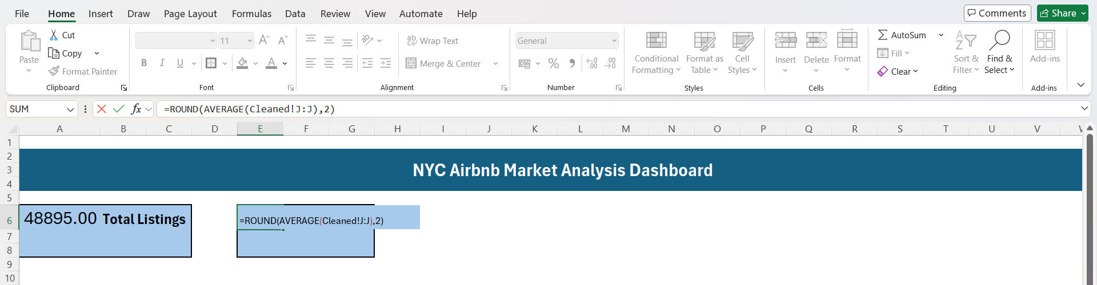
Average Price = $154.78

KPI 3: Total Reviews
Calculates the total number of reviews across all listings.
Formula Used:
=SUM(L2:L955)
Result:
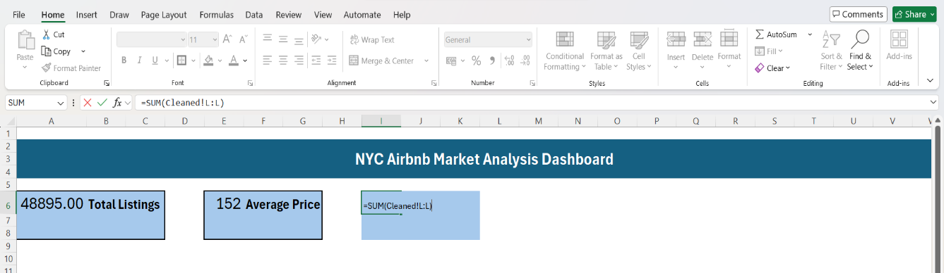
79,000+ Reviews

KPI 4: Average Availability
Calculates the average number of available days per year.
Formula Used:
=AVERAGE(M2:M955)
Result:
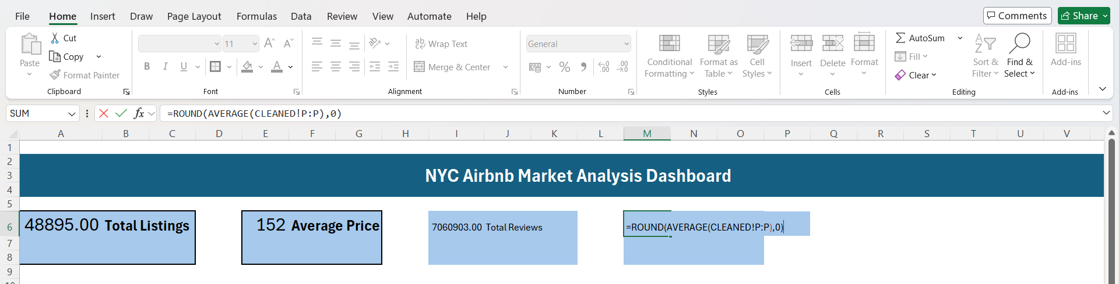
171.44 Days

Slicers Added
Interactive slicers were included to improve dashboard usability.
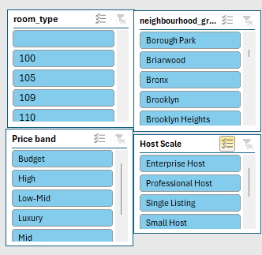
Slicers Used
- Room Type
- Borough
- Price Band
- Host Scale

Benefits:
- Dynamic filtering
- Faster analysis
- Better user interaction

Final Excel Dashboard:
A quick overview of NYC Airbnb market performance through KPI indicators, Pivot Charts, and slicers. It serves as an intermediate analytical layer before developing the advanced Power BI dashboard.
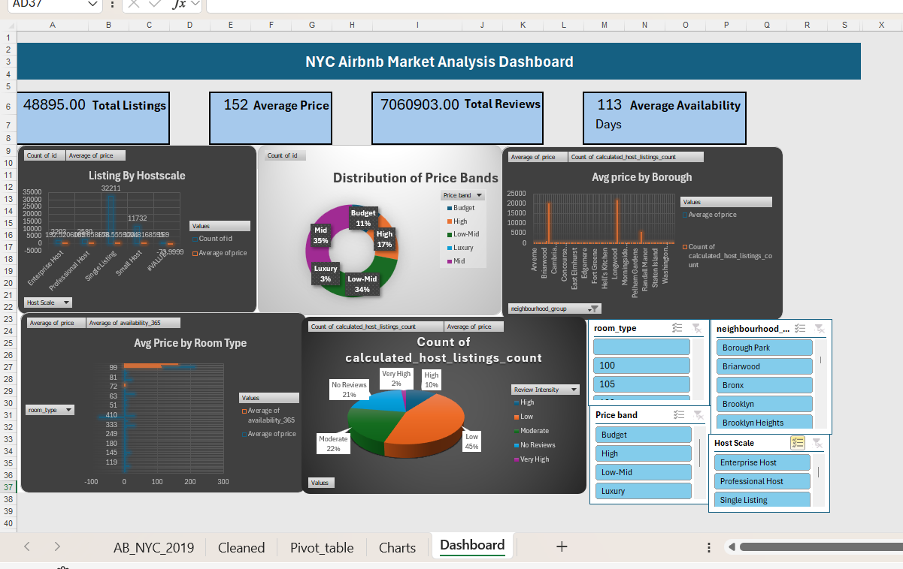

Data Visualization Power BI

Raw Data Import

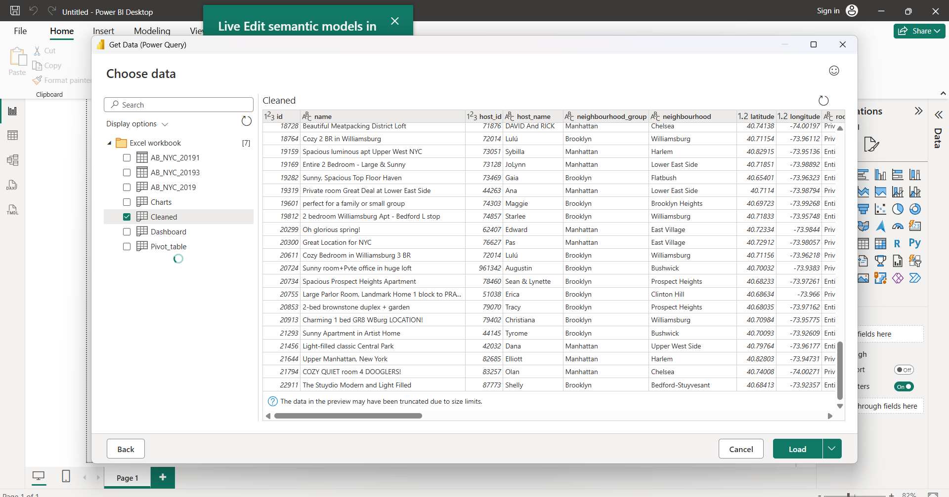
The cleaned Excel dataset containing 1,000 Airbnb listing records was imported into Power BI for visualization and dashboard development.

Cleaned Data View
The transformed dataset containing standardized fields and calculated columns was loaded into Power BI.

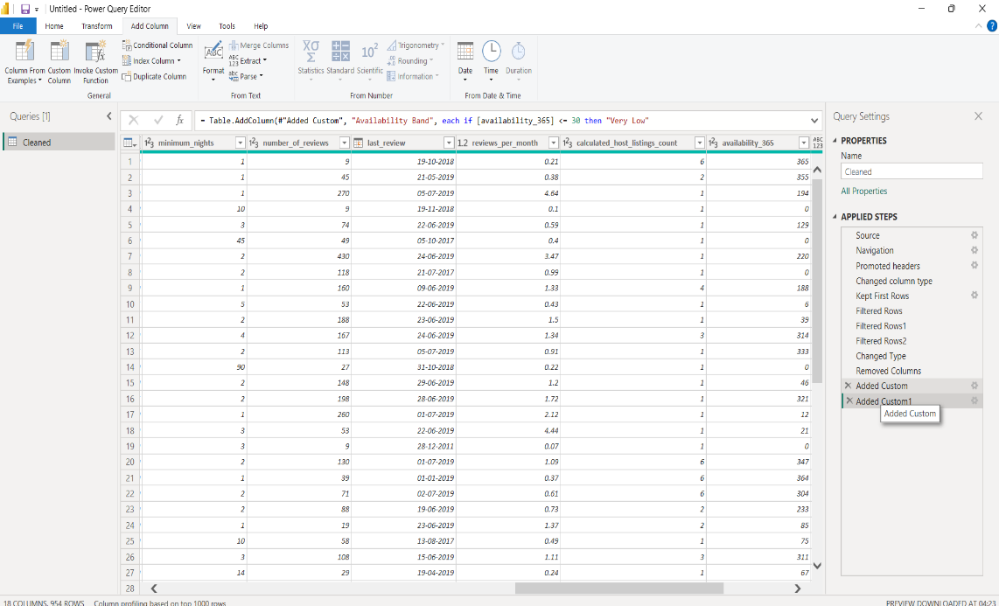

PowerBI Dashboard Development
An interactive dashboard was created using KPI cards, charts, slicers, and map visualizations.

KPI Cards Created
1. Total Listings
2. Average Price
3. Total Reviews
4. Average Availability
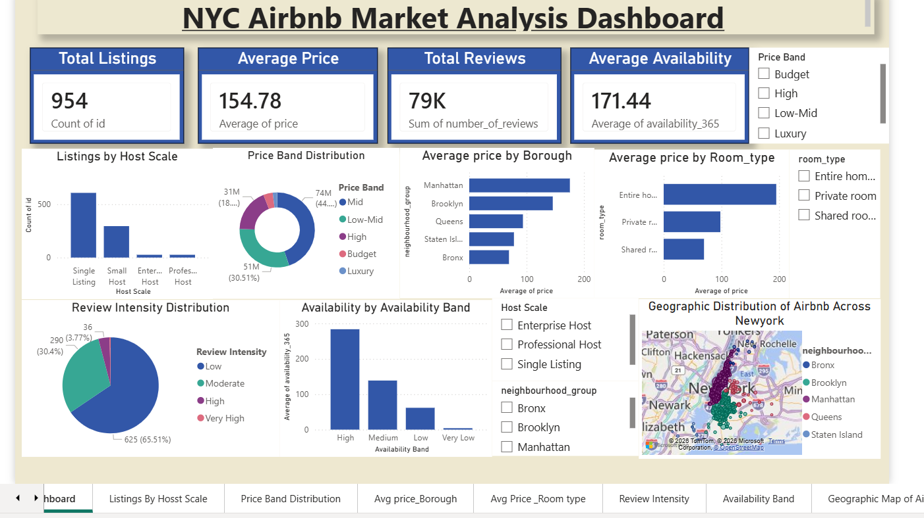

Visualizations Created

1. Listings by Host Scale (Column Chart):-
It Shows the distribution of Airbnb listings among different host categories.
In Distribution of Airbnb listings across Single Hosts, Small Hosts, Professional Hosts, and Enterprise Hosts.

2. Price Band Distribution (Donut Chart):-
Displays the proportion of listings across different pricing categories.
In Distribution of Airbnb listings across Budget, Low-Mid, Mid, High, and Luxury price segments.

3. Average Price by Borough (Bar Chart):-
Compares average listing prices across New York City boroughs.
As Average Airbnb listing price across Manhattan, Brooklyn, Queens, Bronx, and Staten Island.

4. Average Price by Room Type (Bar Chart):-
Shows pricing differences among room categories.
Comparison of average listing prices by room type.

5. Review Intensity Distribution (Pie Chart):-
Displays the distribution of review activity levels among listings.Review intensity levels categorized as Low, Moderate, High, and Very High.

6. Average Availability by Availability Band (Column Chart):-
Analyzes listing availability patterns. In Average listing availability across different availability categories.

7. NYC Airbnb Location Map (Map Visual):-
Visualizes listing locations using Latitude and Longitude coordinates.Geographic distribution of Airbnb listings across New York City. Bubble locations represent listing positions, while bubble size reflects relative listing price levels.

Key Findings

- Manhattan recorded the highest average Airbnb prices.

- Entire Home/Apartment listings were generally more expensive than Private Rooms.

- Most hosts managed only a single property listing.

- Mid-range and Low-Mid price categories dominated the dataset.

- Brooklyn and Manhattan accounted for the highest concentration of Airbnb listings.

- Listings with higher review counts tended to have greater market visibility



Conclusion
The NYC Airbnb Market Analysis project successfully transformed raw Airbnb listing data into meaningful business insights through Excel preprocessing and Power BI visualization. The dashboard effectively highlights market behavior, host activity, pricing trends, review performance, and geographic distribution of listings across New York City.

Future Improvements

- Price Prediction algorithms such as Linear Regression, Random Forest, can be used to predict Airbnb listing prices based on factors such as location, room type, reviews, and availability.

- Future analysis can estimate occupancy rates and potential annual revenue for hosts using historical booking and review patterns.

- Advanced map visualizations such as heat maps and density maps can be developed to identify Airbnb hotspots and high-demand neighborhoods across New York City.

- Customer review text can be analyzed using Natural Language Processing (NLP) techniques to understand guest satisfaction and identify common issues.

- Historical review and booking trends can be examined to understand seasonal demand patterns and market fluctuations throughout the year.

-END OF REPORT-

